LAB EXP 2-5
HARISH KUMAR .M
192411202
SUB:THEORY OF COMPUTATION
CODE:CSA1303

2. Write a C program to simulate a Deterministic Finite Automata (DFA) for the given language representing strings that start with 0 and end with 1

#include <stdio.h>
#include <string.h>
int main()
{
char str[100];
int i, len;

printf("Enter a binary string: ");
scanf("%s", str);

len = strlen(str);

if (str[0] != '0')
{
printf("String Rejected");
return 0;
}

for (i = 0; i < len; i++)
{
if (str[i] != '0' && str[i] != '1')
{
printf("String Rejected");
return 0;
}
}

if (str[len - 1] == '1')
printf("String Accepted");
else
printf("String Rejected");

return 0;
}
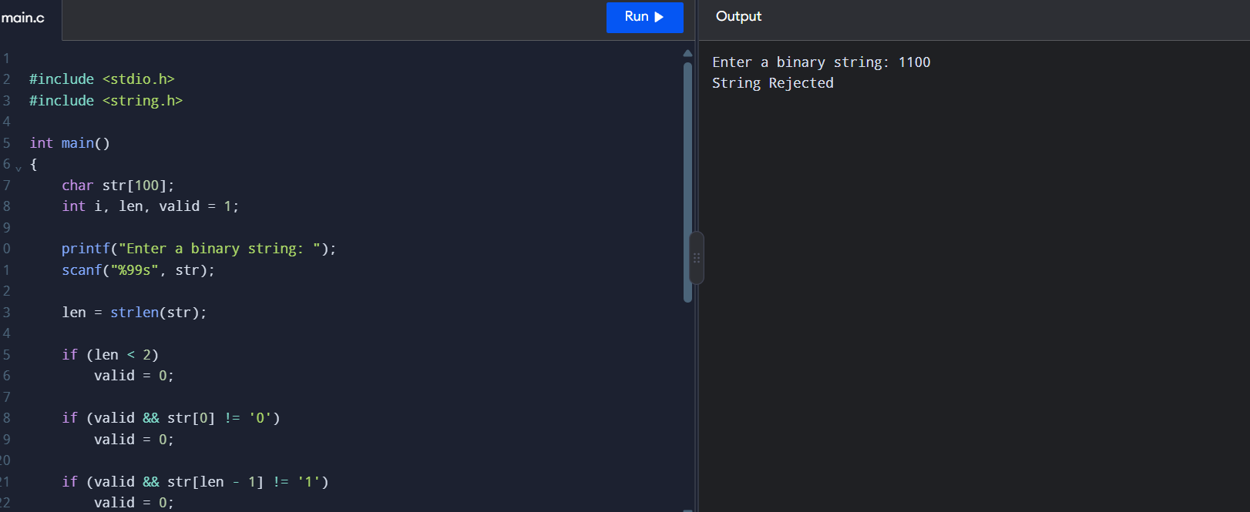
EXP 3:Write a C program to check whether a given string belongs to the language defined by a Context Free Grammar (CFG) S → 0A1 A → 0A | 1A | ε
#include <stdio.h>
#include <string.h>

int main()
{
char str[100];
int i, len, valid = 1;

printf("Enter a binary string: ");
scanf("%99s", str);

len = strlen(str);

if (len < 2)
valid = 0;

if (valid && str[0] != '0')
valid = 0;

if (valid && str[len - 1] != '1')
valid = 0;

for (i = 0; i < len; i++)
{
if (str[i] != '0' && str[i] != '1')
{
valid = 0;
break;
}
}

if (valid)
printf("String Accepted\n");
else
printf("String Rejected\n");

return 0;
}
Output
Enter a binary string: 0101
String Accepted
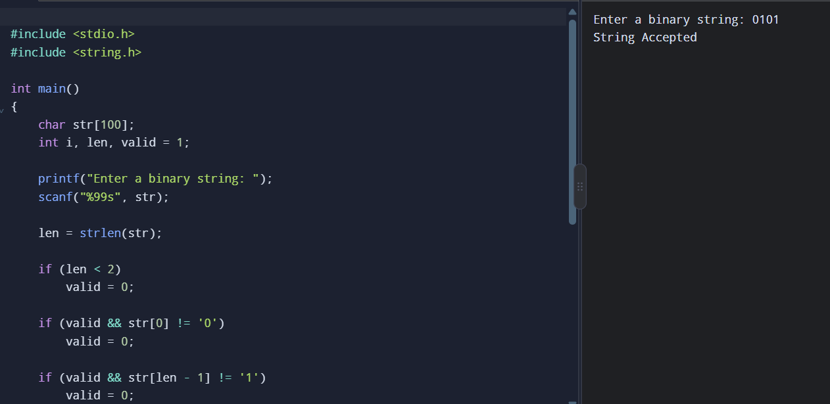

EXP4: Write a C program to check whether a given string belongs to the language defined by a Context Free Grammar (CFG) S → 0S0 | 1S1 | 0 | 1 | ε

#include <stdio.h>
#include <string.h>

int main()
{
char str[100];
int i, len, valid = 1;

printf("Enter a binary string: ");
scanf("%99s", str);

len = strlen(str);

for (i = 0; i < len; i++)
{
if (str[i] != '0' && str[i] != '1')
{
valid = 0;
break;
}
}

if (valid)
{
for (i = 0; i < len / 2; i++)
{
if (str[i] != str[len - i - 1])
{
valid = 0;
break;
}
}
}

if (valid)
printf("String Accepted\n");
else
printf("String Rejected\n");

return 0;
}
Output
Enter a binary string: 0110
String Accepted
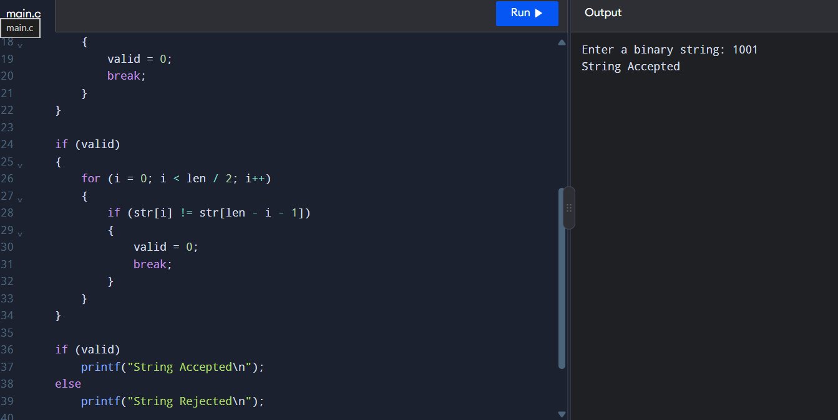
EXP:5: Write a C program to check whether a given string belongs to the language defined by a Context Free Grammar (CFG) S → 0S0 | A A → 1A | ε.
#include <stdio.h>
#include <string.h>

int main()
{
char str[100];
int i, j, len, valid = 1;

printf("Enter a binary string: ");
scanf("%99s", str);

len = strlen(str);

for (i = 0; i < len; i++)
{
if (str[i] != '0' && str[i] != '1')
{
valid = 0;
break;
}
}

i = 0;
j = len - 1;

while (valid && i < j && str[i] == '0' && str[j] == '0')
{
i++;
j--;
}

while (valid && i <= j && str[i] == '1')
{
i++;
}

if (i <= j)
valid = 0;

if (valid)
printf("String Accepted\n");
else
printf("String Rejected\n");

return 0;
}
Output
Enter a binary string: 00100
String Rejected
